**Lab: IAM Billing Access and Budget Configuration**

**Services Used: IAM**

Users created even with admin privilege will not have Billing & Cost Management access. In this lab we are providing Billing & Cost Management to the new admin user created in previous exercise.

Below is the access denied error we get even with admin privileges.

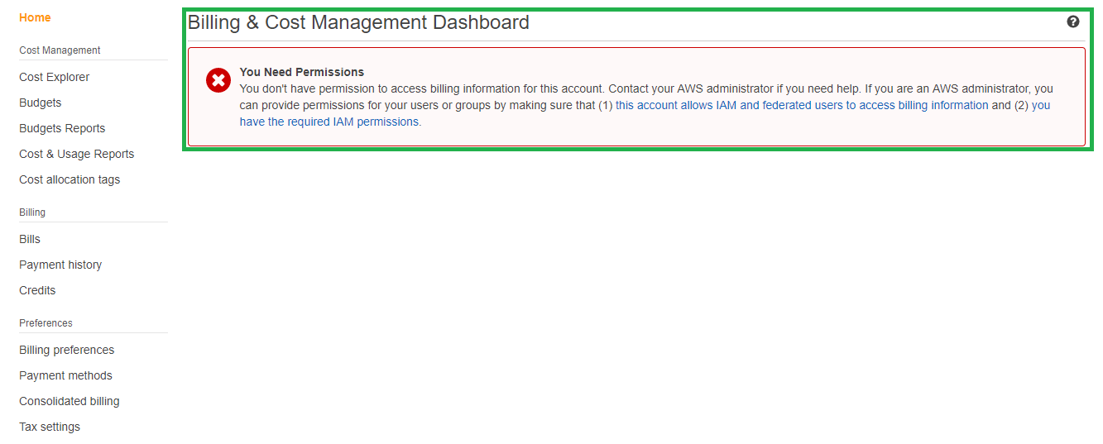

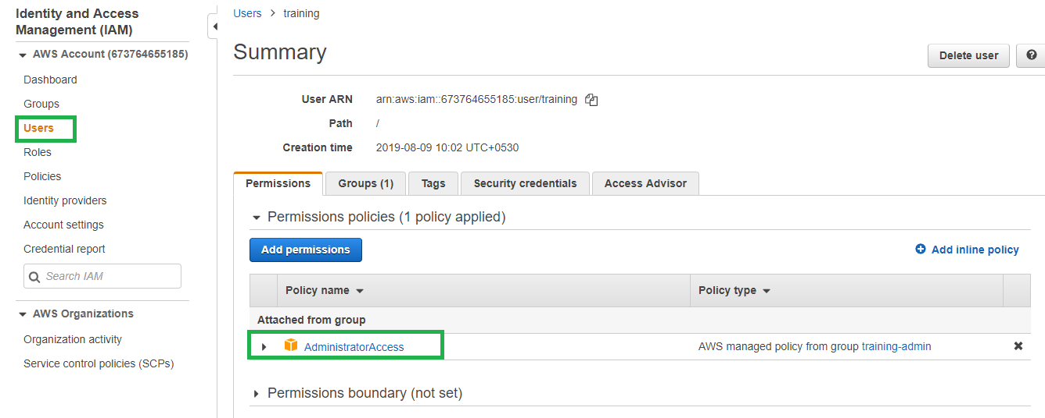

1. Login to AWS Console as root user.
2. Verify the user has either Admin access or billing full access policy attached. In our below example user has Adminaccess which includes billing as well.

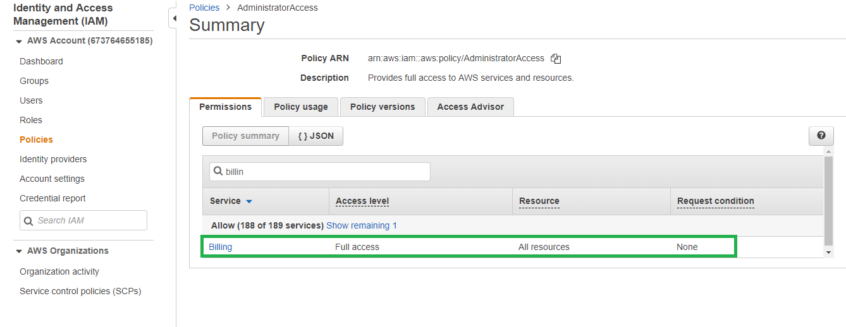

1. Click Account 🡪 My Account.

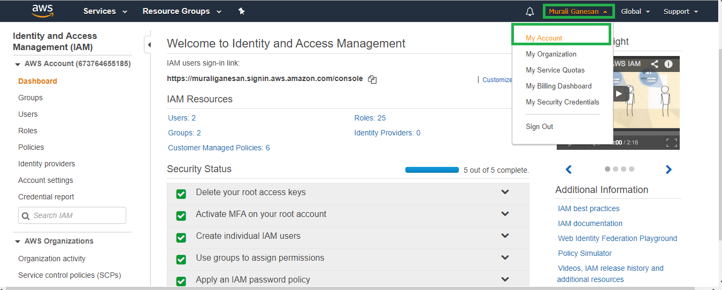

1. Scroll down to IAM User and Role Access to billing information section and edit.

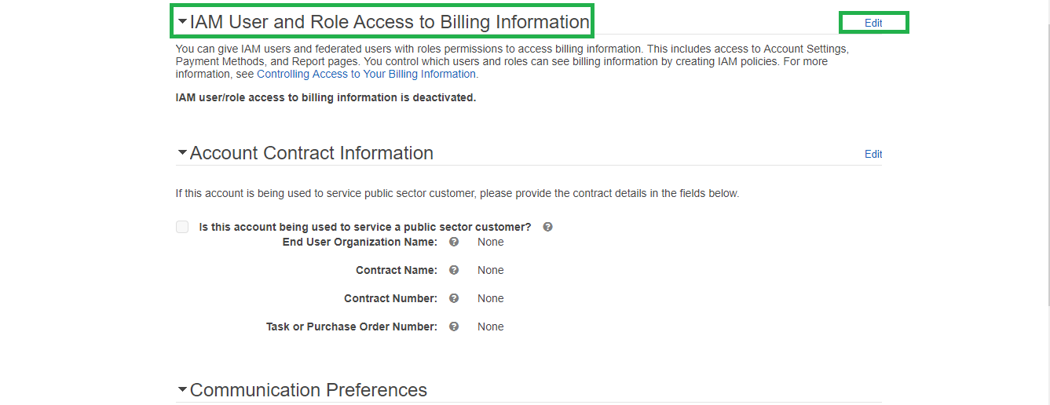

1. Activate IAM Access and select update.



1. Logout root and login as admin user and verify billing dashboard is accessible now.

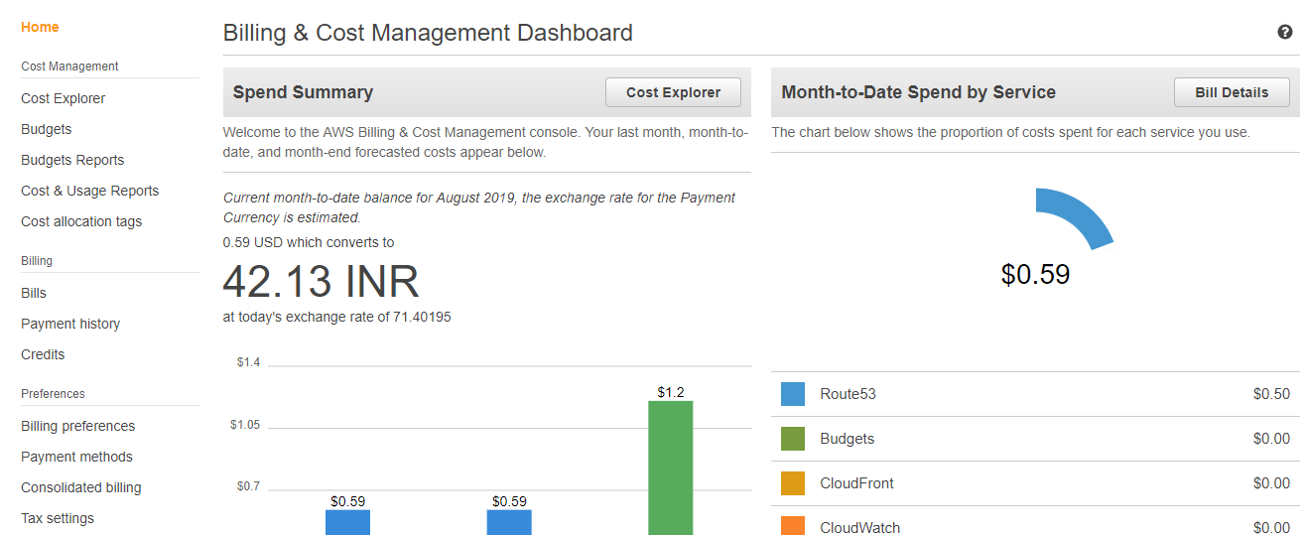

Now billing dashboard is accessible we can configure Budget and alerts to let us know if certain limit reaches in our account.

1. In the billing dashboard select budgets.
2. Create budget

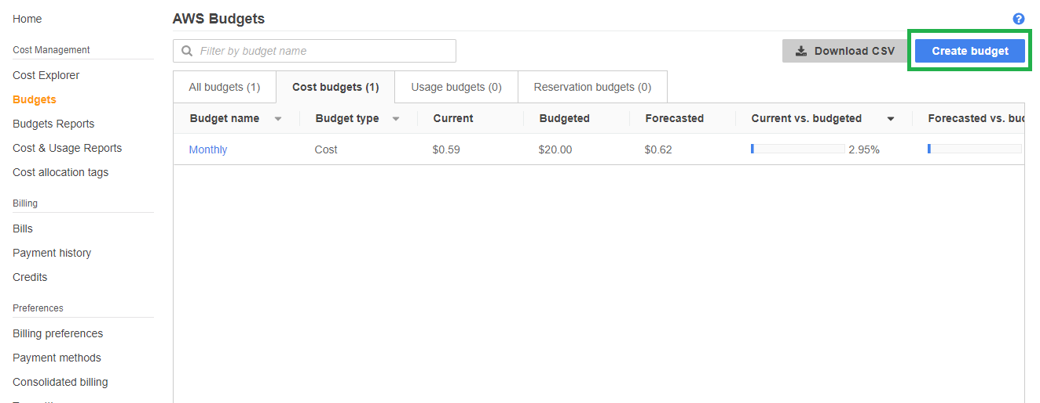

1. Select cost budget and click set your budget.

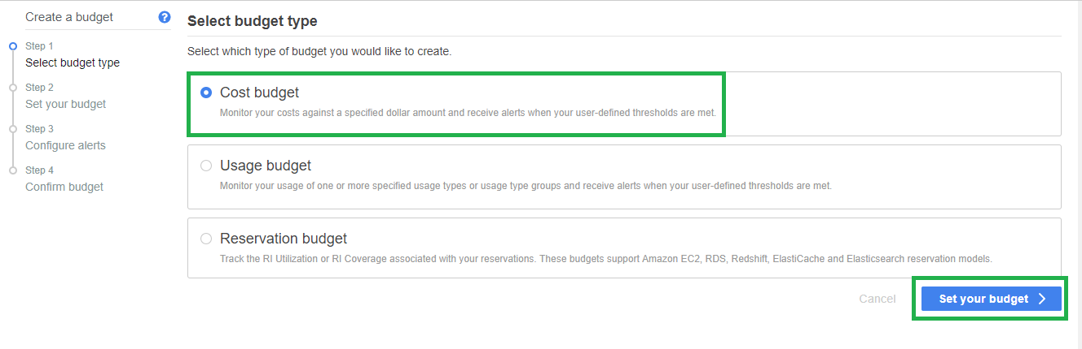

1. Provide Name, Period, and other information’s as mentioned below. For the budget amount mention the amount and click configure alerts.

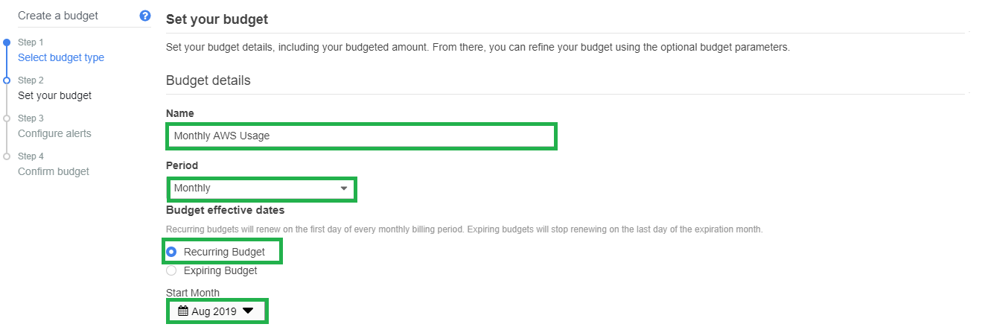

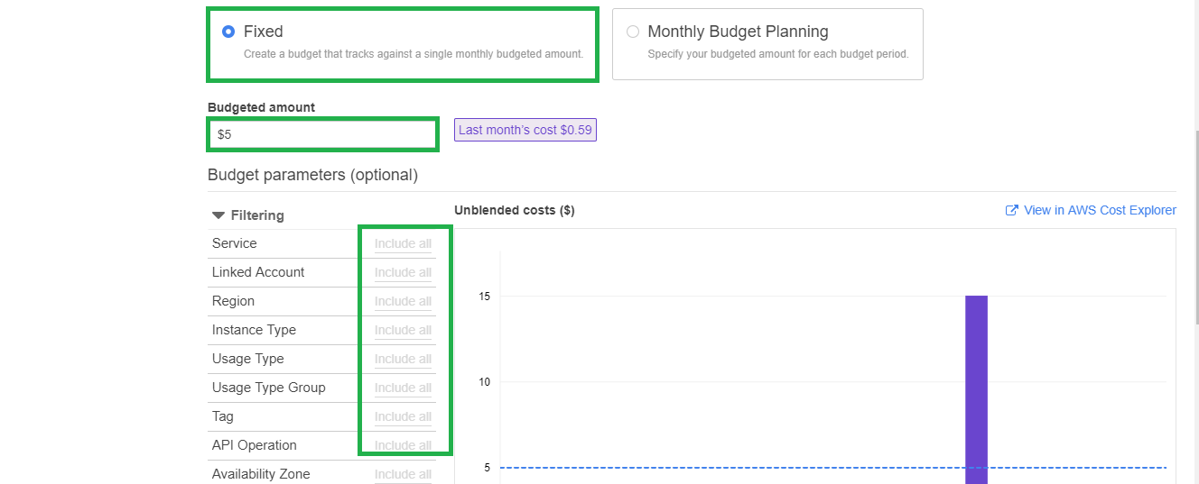

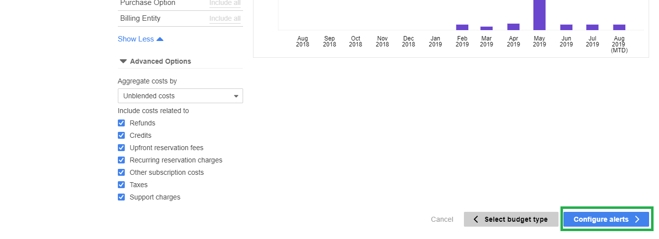

1. In the alert section configure the threshold as 50 so that AWS will alert you if the account usage cost reaches 50% of the budgeted amount. Provide valid email to receive alerts.

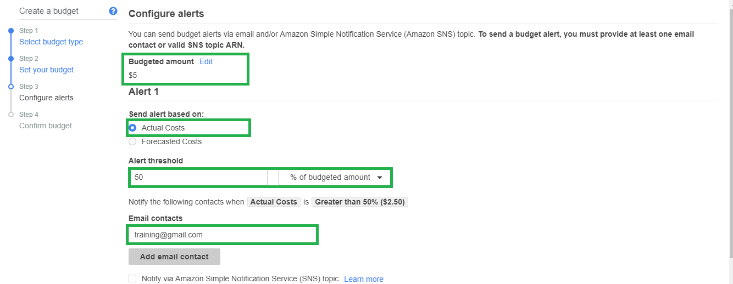

1. Create budget and verify.

